**Imtiyaaz Moses**

Phone: 071 672 4663 - Email: [mosesimtiyaaz@gmail.com](mailto:mosesimtiyaaz@gmail.com)

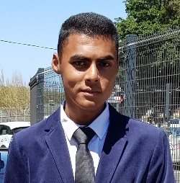

PROFILE

I have a keen interest to gain work experience with your company. I am currently a learner at South Peninsula High School and will be matriculating during December 2018. Since I have a strong interest in Finance, I hope to put my interest and experience into practice.

EDUCATION

2016 - 2018

**South Peninsula High School:** Grade Ten till Twelve with the following subjects; English, Afrikaans, Business Studies, Accounting, Pure Mathematics, Life Science and Life Orientation.

2014 - 2015

**Grassy Park High School:** Grade Eight and Grade Nine

ACHIEVEMENTS

EXPERIENCE

Cassim Medical

Anesthetics

2016 - presentCasual vacation and weekend work. Assisting the Medical Engineer with technical work, assembling and servicing the veterinary anaesthetic machines.

SKILLS

Software

License

Hobbies

Microsoft Office, Windows 2016 Class AB driving license

REFERENCES

Gymming, soccer and gaming

Ms. F. Myburgh Head of Department Commerce

South Peninsula High School

Telephone 021 712 9318

Ms. S Reid – Jacobs Class Teacher

South Peninsula High school

Telephone 021 712 9318